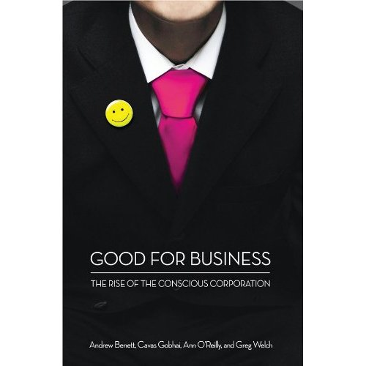

Good For Business:
The Rise of the Conscious Corporation

A Book Review

We live in a free market. If a corporation wants to stay competitive, it needs to move its operations to a place where costs, taxes, and regulations are negligible. As long as consumers keep buying a company’s goods, it can operate any way it wants.

That is so 1990s.

Businesses no longer operate as islands, according to the authors of Good for Business: The Rise of the Conscious Corporation. In an Internet-savvy, skeptical, and tumultuous 21st century, societal goodwill becomes more than a luxury. It becomes a business imperative.
“Those corporations (who) have taken the humanization of business into their brand DNA…will have the greatest influence with policymakers (of the future) and the best chance of engaging talent, consumers, and investors alike,” say the authors (p. 185).

Many things have changed for corporations during the past decade. Public scrutiny has become a norm, thanks to open Internet channels. To stay competitive in today’s busy, hypercompetitive markets, companies need to refine their brand images. In an age where a reputation can burn in seconds, soft assets like trust and emotional connection are more important than ever. Tomorrow’s leaders (today’s millennial generation) require a different kind of workplace than their forebears.

How do you stay successful in a changed environment?
Good for Business covers how these changes came about, what they mean, and what to do about them in a three-part book. The first part offers an overview of how the role of the corporation has changed in today’s (post-crisis, millennial) era. It illustrates how consumers have become more aware of who they’re buying from, more networked into opinion groups, and more powerful overall. It explains what that all means for corporate brands. It also introduces the four cornerstones of tomorrow’s successful, conscious corporation: A purpose beyond profit, a people-centered culture, a sustainable approach to business, and respect for consumers’ power.

The second part of the book describes why corporate brands have become so important, and how companies can empower effective brand messengers. It also covers what it means to be a leader in tomorrow’s successful corporation (Leader of Tomorrow). In addition, it explains how to create a culture that engages millennials (the Talent of Tomorrow).

The third part of the book talks about building a useful statement of direction for your conscious corporation, then embedding and sustaining it within your company. This chapter is almost like a workbook, detailing exactly what you need to do and why.

The book concludes with examples of corporations that have good consumer perception of their brand and company. The appendix offers a couple of global marketing study results on the way people consume products and perceive companies.

